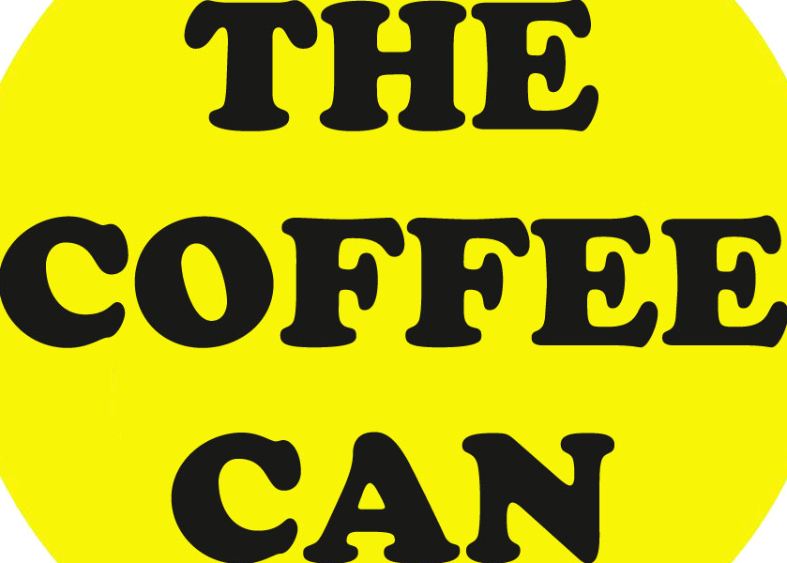
Optional Extras

Additional Coffee
$4.00 +GST per cup
(over the pre-purchased amount)
Additional Barista
$50.00 +GST per hour
Cold Brew
$4.00 + GST per cup
Coffee Cart Branding — Front Panel
$220.00 +GST
Cup Branding - Stickers
(includes application)
$1.00 +GST per cup
Cup Branding - Stamp
(includes application)
“Keep your stamp!”
$150.00 +GST
Personalised cookies
$4.00 +GST (min order 50)
Mixed Sweet Treats Platter
$40 +GST (20 serves each)
Slushie Machine
(2 Barrel)
$150.00 +GST
Slushie Machine
(3 Barrel)
$250.00 +GST
The Coffee Can
28 Michaelangelo Drive
Redlynch
QLD 4870

Tel: 0434906171
Email: thecoffeecancafe@mail.com
www.facebook.com/coffeecancafe

